**Exception program**

#include<iostream>

using namespace std;

void test(int x)

{

try

{

if(x>0)

throw x;

else

throw 'x';

}

catch(int x)

{

cout<<"catch an integer:"<<x;

}

catch (char x)

{

cout<<"catch an char"<<x;

}

}

int main()

{

cout<<"test";

test(10);

test(0);

}

**OUTPUT**

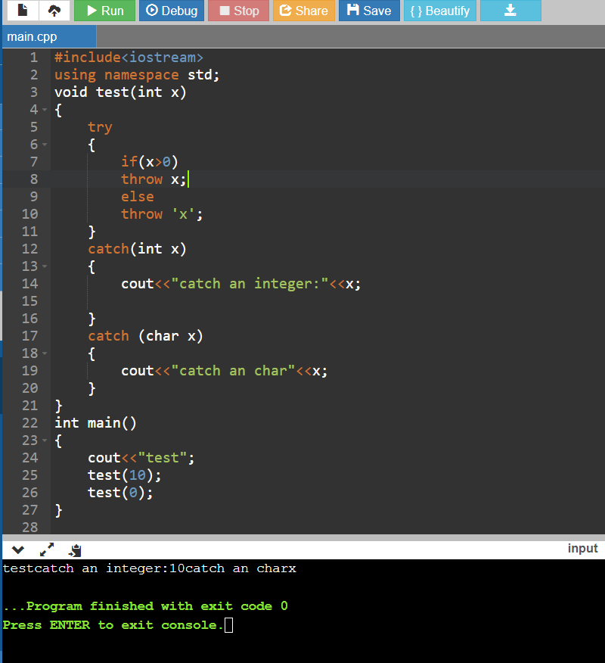

**Sorting Ascending order**

#include<iostream>

using namespace std;

int main()

{

int arr[100];

int size,i,j,temp;

cout<<"enter the size of array:";

cin>>size;

cout<<"enter elements in array:";

for(i=0;i<size;i++)

{

cin>>arr[i];

}

for(i=0;i<size;i++)

{

for(j=i+1;j<size;j++)

{

if(arr[j]<arr[i])

{

temp=arr[i];

arr[i]=arr[j];

arr[j]=temp;

}

}

}

cout<<"elements of array in sorted acending order"<<endl;

for(i=0;i<size;i++)

{

cout<<arr[i]<<endl;

}

return 0;

}

**OUTPUT**

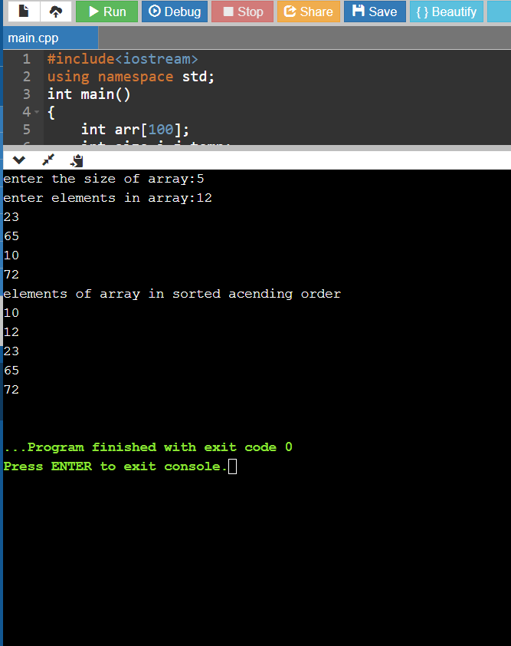

**Sorting descending order**

#include <iostream>

using namespace std;

#define MAX 100

int main()

{

int arr[100];

int n,i,j;

int temp;

cout<<"Enter total number of elements to read: ";

cin>>n;

if(n<0 || n>MAX)

{

cout<<"Input valid range!!!"<<endl;

return -1;

}

for(i=0;i<n;i++)

{

cout<<"Enter element ["<<i+1<<"] ";

cin>>arr[i];

}

cout<<"Unsorted Array elements:"<<endl;

for(i=0;i<n;i++)

cout<<arr[i]<<"\t";

cout<<endl;

//sorting - Descending ORDER

for(i=0;i<n;i++)

{

for(j=i+1;j<n;j++)

{

if(arr[i]<arr[j])

{

temp =arr[i];

arr[i]=arr[j];

arr[j]=temp;

}

}

}

//print sorted array elements

cout<<"Sorted (Descending Order) Array elements:"<<endl;

for(i=0;i<n;i++)

cout<<arr[i]<<"\t";

cout<<endl;

return 0;

}

**OUTPUT**

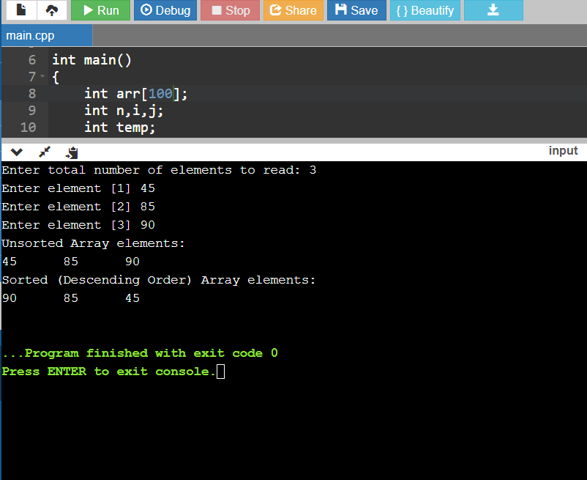

**Namespace Program**

#include<iostream.h>

using namespace std;

namespace apple

{​​​​

void print(const char* test)

{​​​​

std::string temp=test;

std::reverse(temp.begin(), temp.end());

std::cout<<temp<<std::endl;

}​​​​

}​​​​

int main()

{​​​​

using namespace a=apple;

a::print("Alliance");

}​​​​

